Grade 7/8 Music
Final Music Evaluation – Choose Your Own Adventure!

- Choose to write your own rhythm (Column A) or to use a rhythm provided by
Mrs. Aly (Column B)

- Choose your level of difficulty (1 instrument vs 2 instruments vs 3 instruments)

A – Write your own | B – Use provided rhythm
Level 1  Create a rhythm to be played with 1 instrument. Consider accenting certain beats and using different note durations. | Level 1  Copy the rhythm below,  which includes 1 instrument.  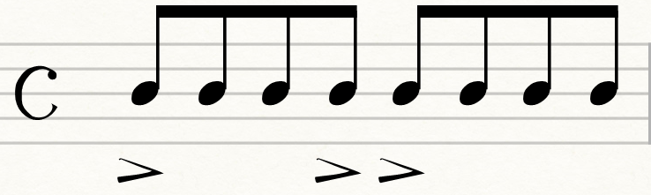
Level 2  Create a rhythm to be played with 2 instruments. Consider which drums you will use in your performance. | Level 2  Copy the rhythm below, which  includes 2 instruments. Consider which drums  you will use in your performance.  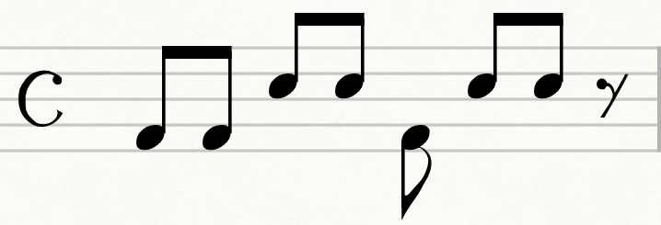
Level 3  Create a rock beat to be played using 3 drums (hi-hat, snare drum, and bass drum). | Level 3  Copy the rock beat below, which uses 3 drums  (hi-hat, snare drum, and bass drum).  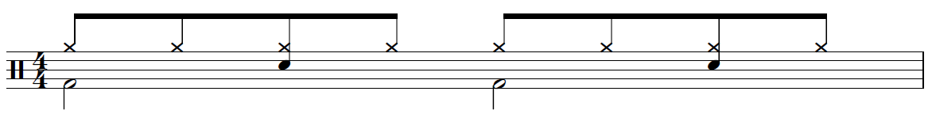

- On evaluation day, you will be asked to submit your written rhythm, and perform it.

